EER is a high-level data model that incorporates the extensions to the original ER model. Enhanced ERD are high level models that represent the requirements and complexities of complex database.

In addition to ER model concepts EE-R includes −

* Subclasses and Super classes.
* Specialization and Generalization.
* Category or union type.
* Aggregation.

These concepts are used to create EE-R diagrams.

### Supertypes and Subtypes

* Supertype - an entity type that relates to one or more subtypes.
* Subtype - a subgroup of entities with unique attributes.
* Inheritance - the concept that subtype entities inherit the values of all supertype attributes.

Note: subtype instances are also classified as supertype instances.

### Generalization & Specialization

* Generalization - the process of defining a general entity type from a collection of specialized entity types.
* Specialization - the opposite of generalization, since it defines subtypes of the supertype and determines the relationship between the two.

**Subclasses and Super class**

Super class is an entity that can be divided into further subtype.

For **example** − consider Shape super class.

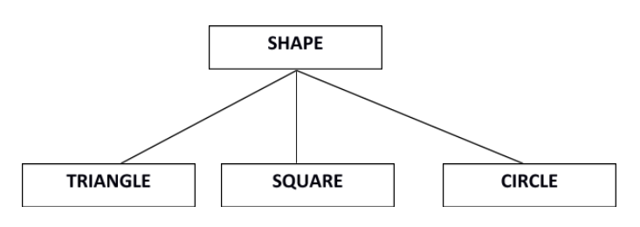

Super class shape has sub groups: Triangle, Square and Circle.

Sub classes are the group of entities with some unique attributes.Sub class inherits the properties and attributes from super class.

**Specialization(TOPDOWN APPROACH) and Generalization(BOTTOMUP APPROACH)**

Generalization is a process of generalizing an entity which contains generalized attributes or properties of generalized entities.

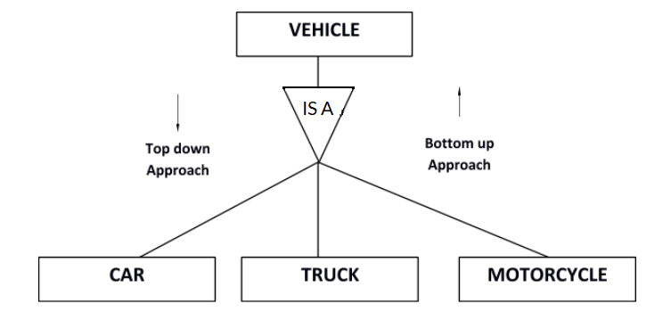

It is a Bottom up process i.e. consider we have 3 sub entities Car, Truck and Motorcycle. Now these three entities can be generalized into one super class named as Vehicle.

Specialization is a process of identifying subsets of an entity that share some different characteristic. It is a top down approach in which one entity is broken down into low level entity.

In above example Vehicle entity can be a Car, Truck or Motorcycle.

**Category or Union**

Relationship of one super or sub class with more than one super class.

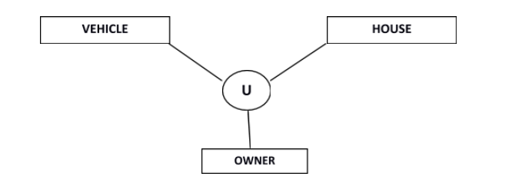

Owner is the subset of two super class: Vehicle and House.

**Aggregation**

Represents relationship between a whole object and its component.

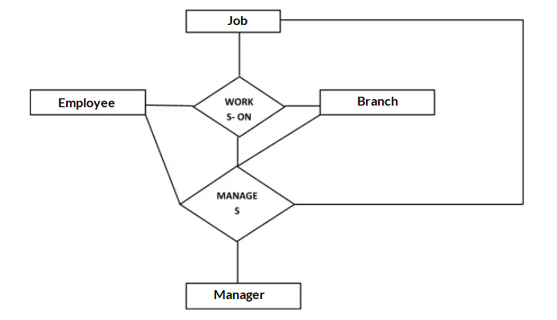

Consider a ternary relationship Works_On between Employee, Branch and Manager. Now the best way to model this situation is to use aggregation, So, the relationship-set, Works_On is a higher level entity-set. Such an entity-set is treated in the same manner as any other entity-set. We can create a binary relationship, Manager, between Works_On and Manager to represent who manages what tasks.

Aggregration is a process when relation between two entities is treated as a **single entity**.

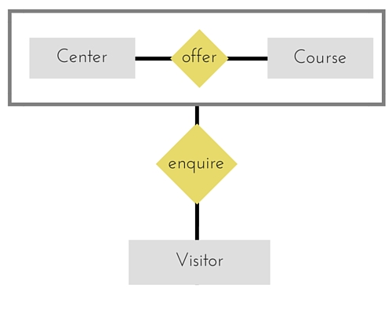

In the diagram above, the relationship between **Center** and **Course** together, is acting as an Entity, which is in relationship with another entity **Visitor**. Now in real world, if a Visitor or a Student visits a Coaching Center, he/she will never enquire about the center only or just about the course, rather he/she will ask enquire about both.

## When to use which

Overall, both diagrams provide the ability to design your database with precision.

An ER diagram gives you the visual outlook of your database. It details the relationships and attributes of its entities, paving the way for smooth database development in the steps ahead.

EER diagrams, on the other hand, are perfect for taking a more detailed look at your information. When your database contains a larger amount of data it is best to turn to an enhanced model to more deeply understand your model.

So when should you use which? Honestly, both are useful, and it depends mostly on the size and detail of your data. The more complicated the data, the more likely you’ll need to use an EER diagram to make sure you’re properly organizing every relationship.

Both diagrams make designing your database easier than ever. All you need is a great [diagramming tool](https://cacoo.com/examples/database-erd-software) to give you the templates, shapes, and notations you need to create your ER and EER diagrams in a flash.